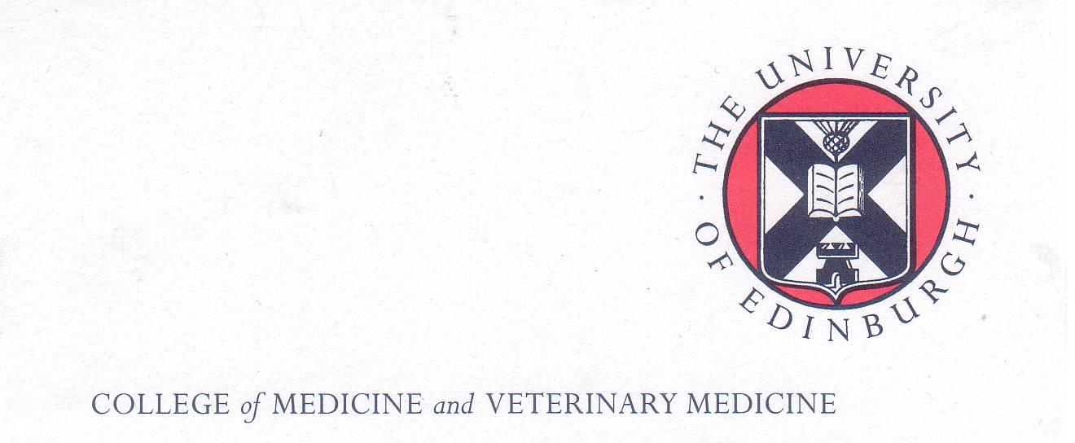
The Boloz-Kulesza Trust Fund and
Polish School of Medicine Memorial Fund
Scholarship Programmes 2021/22

Call for Scholarship Applications
42nd Edinburgh Clinical Neurology Course Tuesday 5th October 2021

Introduction
The Bóloz-Kulesza Trust Fund and the Polish School of Medicine Memorial Fund support thriving scholarship programmes which enable successful applicants to undertake a period of further study or research at The University of Edinburgh Medical School and related institutions.

The Course: This annual course has now been running in Edinburgh for over 40 years.
Due to the Covid-19 pandemic, this year’s course will be a one day, on-line event with a practical emphasis for anyone with an interest in neurology.

“The programme has a practical approach that will appeal to everyone with a passing interest in neurology, whether trainees, young(ish) consultants or seasoned veterans. This "no nonsense" approach, instilled by its founder Charles Warlow, is the central attraction of the course, together with its own unique brand of informality and Scottish conviviality.”
The course will be recorded and will be available for catch up after the course.

For further details of the topics and speakers please go to: Edinburgh Clinical Neurology course | The University of Edinburgh

The Scholarship: The Boloz-Kulesza Trust Fund and the Polish School of Medicine Memorial Fund will sponsor a total of 4 places on this course. Each scholarship will cover the cost of the course fee of £35.

Eligibility

These scholarships are open to Polish medical scientists /neurologists working in clinical research who are:
- in their early career (usually within 10 years of their medical graduation - MB ChB equivalent)
- working in Polish Medical Academies/Universities and Research Institutes
- committed to the further development of expertise in the field of clinical neurology in Poland and
- have excellent mastery of English .

Successful applicants are:
- expected to meet the general criteria for the award of these scholarships;
- attend the full course, not arrive late and/or depart early;
- submit a short report of their experience on the course by e-mail to the Scholarships Coordinator within one month of its completion

Note: The expectation and intention of the founders of both The Polish School of Medicine Memorial Fund and the Boloz-Kulesza Trust Fund Scholarship Programmes are that successful applicants will return to their units/ departments in Poland on completion of their attachment/studies, use their new found skills to further enhance and develop Polish medicine including medical research and thus foster academic links between Polish Medical Universities and Research Institutes and The University of Edinburgh.

Names and contact e-mail address of successful applicants will be forwarded to the Course Administrator for enrolment on the course.

How to Apply

1. Applications should be sent electronically to the Scholarship Coordinator, Dr Maria Dlugolecka-Graham MBE (e-mail:PSMscourse@ed.ac.uk by the closing date (17.00hrs Tuesday 21 September 2021). Late applications will NOT be considered

2. Applicants must submit the following documents in support of their application:

- An up to-date CV giving adequate information about their expertise and training in clinical neurology to date. A list of dates and posts held will not suffice;

- A letter of support from their Rektor or vice- rector;

- Documentary evidence of having an adequate mastery of English. Where no externally validated certificate ( eg IELTS, TOEFL or Cambridge Advanced or Proficiency Certificate or equivalent is available, applicants will be required to undergo a Skype or telephone interview to establish the level of their English language skills Applicants must indicate that they agree to this assessment.

- A statement ( of no more than 500 words) of why they wish to be considered for a scholarship and how they personally and their department are likely to benefit from their participation in the course

- A signed statement in which they agree to write a short report of their experience on the course and submit it by e-mail to the scholarship coordinator within 1 month of completing the course.

Note: A template for preparing the report is available but the scholars are not obliged to use it.

Closing date for applications 17.00hrs Tuesday 21st September 2021

For enquiries about applying for these scholarships, please contact:

Dr Maria Dlugolecka-Graham MBE
Polish School of Medicine Coordinator for The University of Edinburgh
College of Medicine & Veterinary Medicine The University of Edinburgh,
Room SU205, Chancellors Building
49 Little France Crescent
Edinburgh EH16 4SB UK

e-mail: PSMscourse@ed.ac.uk

